A binary tree is a data structure in which each node has at most two children, called the left and right child.

Types of Binary Trees:
- Full Binary Tree – Every node has 0 or 2 children.
- Rooted Binary Tree - tree data structure where each node has at most two children (left and right) and one node is designated as the root
- Complete Binary Tree – All levels are fully filled except possibly the last, which is filled from left to right.
- Perfect Binary Tree – All internal nodes have 2 children and all leaves are at the same level.
- Balanced Binary Tree – Height of left and right subtrees of every node differ by at most 1.
- Degenerate (or Skewed) Tree – Each node has only one child, forming a linked list.

Task001 ::

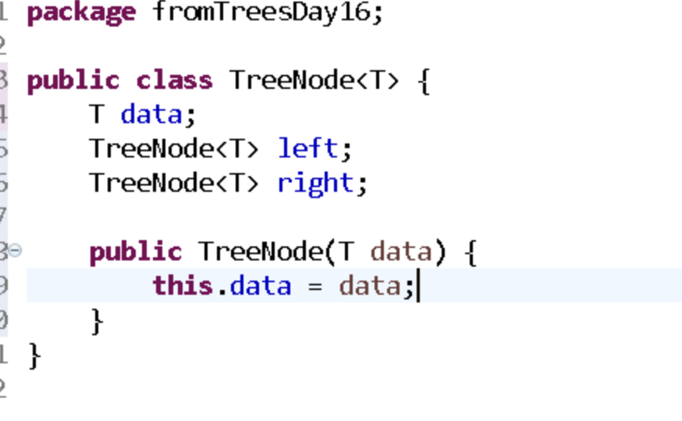

Task002::

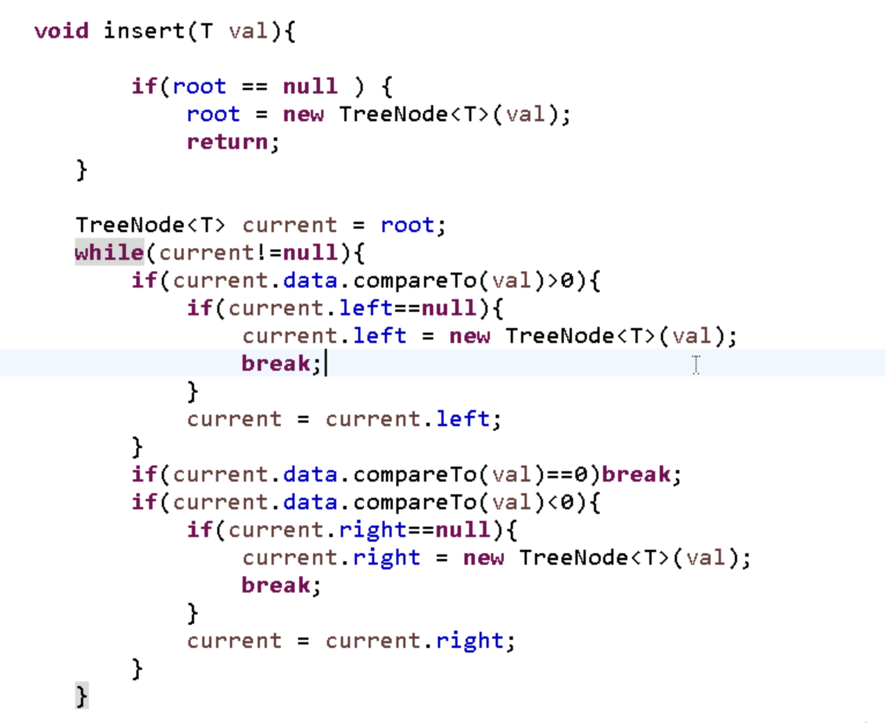

Task003 ::
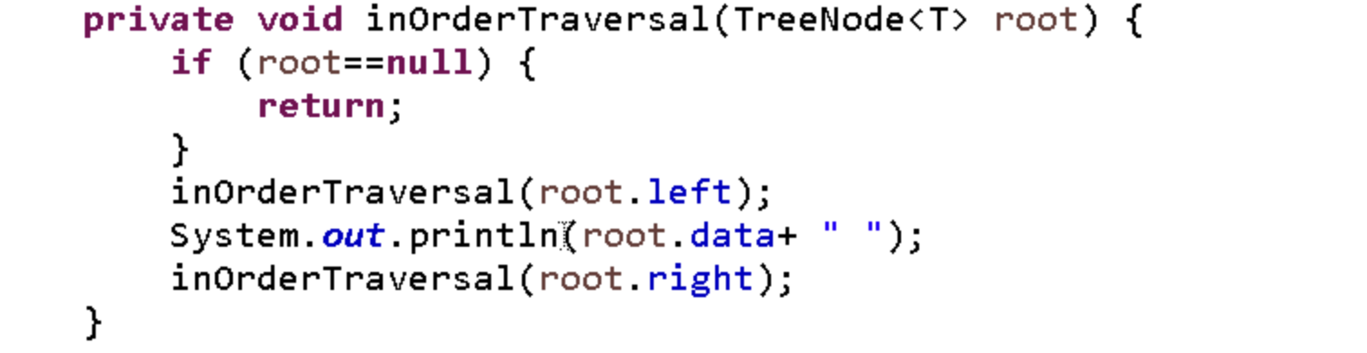

Task004 ::
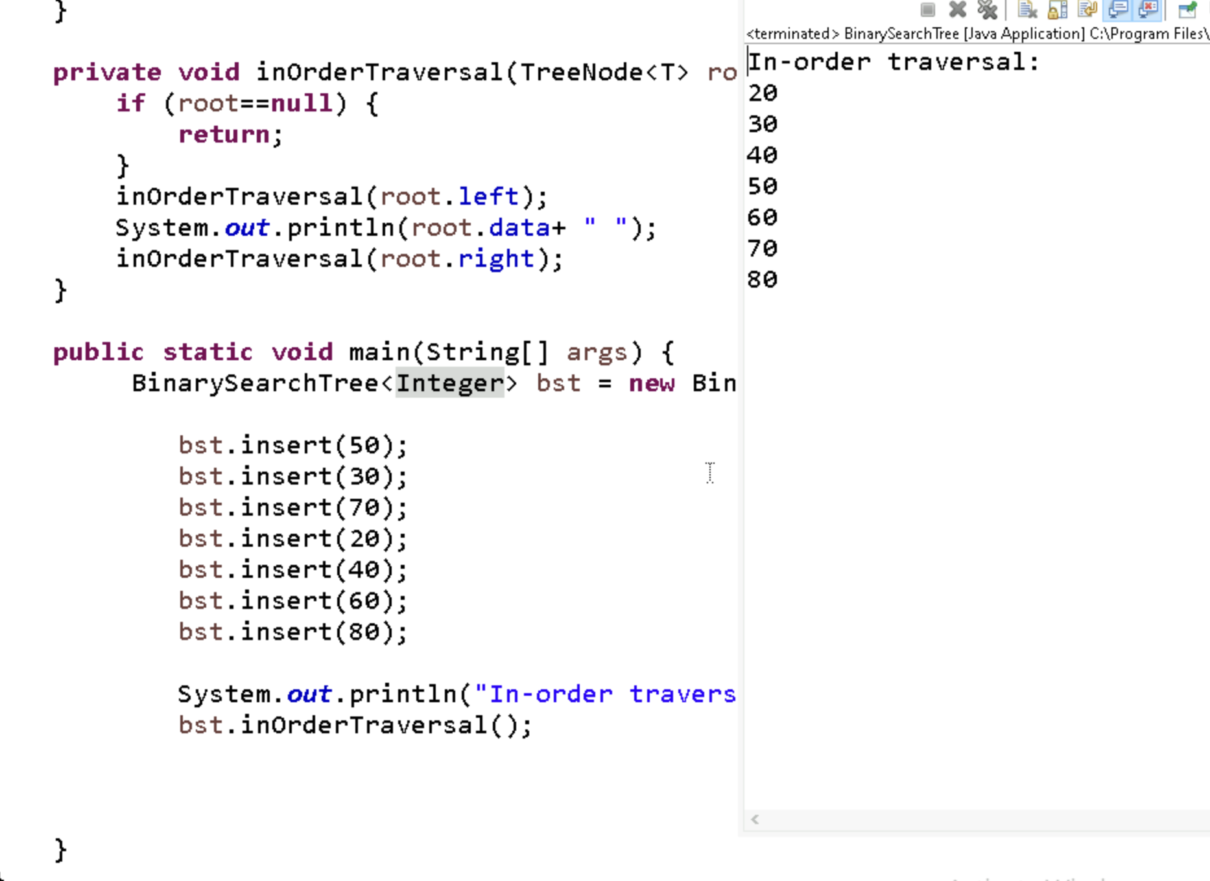

Task005 ::

Applications of Tree
Hierarchical data storage like file systems and organizational charts.
Efficient searching and sorting, e.g., Binary Search Trees, AVL, and Heaps.
File system hierarchy in operating systems is a real-world example of a tree, where directories are nodes and subdirectories/files are children.
Task006::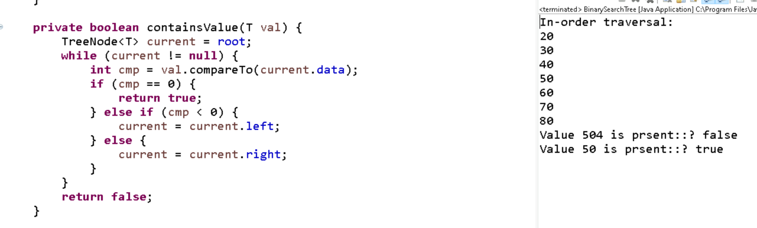

Task007 ::
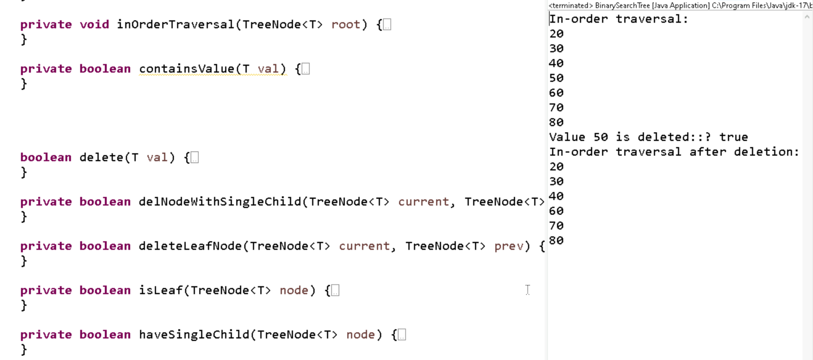

Task009::
Social Networks – Users (nodes), friendships (edges).
Google Maps / GPS – Locations as nodes, roads as edges.
Web Crawlers – Pages are nodes, links are edges.
Network Routing – Devices are nodes, connections are edges.
Recommendation Systems – Products/users as nodes, similarities as edges.
Task Scheduling – Dependencies as directed edges (DAG)

Task 10::
## ✅ Types of Graphs

1. **Directed Graph** – Edges have direction (A → B).
2. **Undirected Graph** – Edges have no direction (A — B).
3. **Weighted Graph** – Edges have weights (A —(5)— B).
4. **Unweighted Graph** – Edges have no weights.
5. **Cyclic Graph** – Contains at least one cycle.
6. **Acyclic Graph** – No cycles (e.g., DAG).
7. **Connected Graph** – All nodes are reachable.
8. **Disconnected Graph** – Some nodes are not connected.

Task11::
